TC-ESC-RSC Switch – CGEA1.3

Functional Description

The purpose of the TC-ESC-RSC Switch is to allow the customer to toggle the state of the Traction Control-ESC-RSC system between ON and OFF.

The DrvSlipCtlMde_B_Rq2 signal correlates the hardwired TC-ESC-RSC switch state and the Operational_Mode to inform the TC-ESC-RSC Controlling ECU of the state of the TC-ESC-RSC switch.

This implementation of this TC-ESC-RSC Switch function is for those TC-ESC-RSC systems where the cluster senses the TC-ESC-RSC Switch and reports the state of the switch to the TC-ESC-RSC ECU via a CAN signal. It is the responsibility of the TC_ESC-RSC ECU to determine the state of the TC-ESC-RSC system and determine the state of all TC-ESC-RSC telltales.

Note that for vehicles supporting MyKey, the TC-ESC-RSC system can be SETUP configured to be always enabled when the current ignition key device is a MyKey. This is accomplished by disabling the switch press information.

AdvanceTrac Hard Button Control config is set to disabled if AdvanceTrac Control Function STSS is used (message center setup feature with confirmation message). Upon applications direction this STSS need not be implemented if it is determined there will never be a hard switch on a given program/programs with common software.

v3.0 of this STSS is NOT backward compatible: v3.0 of this STSS removes the Advancetrac MyKey warning control logic from IPC. Going forward the ABS module is going to control the “AdvanceTrac/Traction Control Always On MyKey Setting” warnings directly using the DrvSlipCtlMdeMsg_D_Rq signal. See Warning-Traction Control OFF_Traction Control ON_Advancetrac OFF_Advancetrac ON - CGEA1.3_v6.0 or later for this function. A program by program roll out plan must be developed for this strategy change.

Interfaces

Interface Context Diagram (I/O Block Diagram)
- TC-ESC-RSC Switch

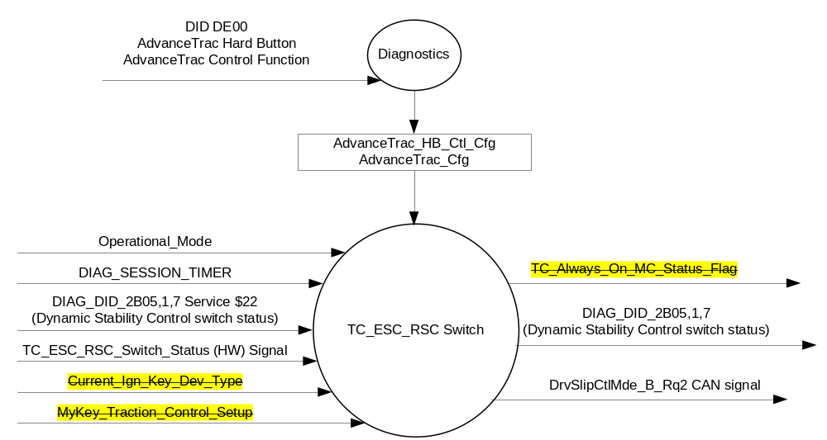

Inputs

      - INTERNAL:
            - DIAG_SESSION_TIMER
            - Operational_Mode
            - DIAG_DID_2B05,1,7 (Dynamic Stability Control switch status)
            - Current_Ign_Key_Dev_Type: Used to indicate the type of key currently in use in the vehicle. See MyKey Control Function SPSS for further definition.
            - MyKey_Traction_Control_Setup: Used to indicate if MyKey Traction Control Disable is On or Off. See MyKey Control Function SPSS for further definition.
      - TC_ESC_RSC_Switch_Status (HW) Signal:
1. To be sensed by a micro A/D input port or Digital port
2. Sensing circuit to sink a minimum current of 7 mAmps at 13.25 Volts thru the TC_ESC_RSC switch.
3. To have 0 to 50 ohm input under all operating voltage conditions to be closed, which relates to a Press of the TC_ESC_RSC Switch.
4. TC_ESC_RSC switch will be closed to ground when pressed.

TC_ESC_RSC  Switch Condition | TC_ESC_RSC  Switch Logic | TC_ESC_RSC  Switch Input | Debounce | TC_ESC_RSC_Switch_Status
Not Pressed | Open | >100k-ohms⁽¹⁾ | 5 samples in a row @10 ms  or 6 samples in a row @8 ms | 0X1 (Not Pressed)
Pressed | Closed | =< 50 ohms | 5 samples in a row @10 ms  or 6 samples in a row @8 ms | 0X0 (Pressed)
(1) Changed from 100 ohms to 100k-ohms to align with ELCOMP RQT-191001-009863 (EC-0015).

Outputs
- TC_Always_On_MC_Status_Flag that is used to control the Warning displayed in the message center when a MyKey is the current ignition key device type.
- DIAG_DID_2B05,1,7 (Dynamic Stability Control switch status)
- Mux Message on the CAN network

- DrvSlipCtlMde_B_Rq2 Signal
Signal Name | Size  (bits) | Detail | Units | Res. | Offset | State  Encoded | Min. | Max.
DrvSlipCtlMde_B_Rq2 | 1 |  | SED | 1 | 0 |  | 0  (0x0) | 1 (0x1)
 |  | Not_Pressed |  |  |  | 0x0
 |  | Pressed |  |  |  | 0x1

Function/Performance

Operational Modes

Mode | Differentiating Vehicle Conditions
Sleep Mode | No sensing of Switch
Limited Mode | No sensing of Switch
Normal Mode | Sensing of Switch
Crank Mode | Sensing of Switch

Voltage Levels

Refer to the Cluster Features table located in the Operational Modes and Voltage Range Strategies Section in this SPSS

Human-Machine Interface

Visual

Indicator Graphics / Display Format
None

Indicator Color Coordinates

N/A

Indicator Characteristics

N/A

Audio

None.

System Accuracy

The output of the state matrix, reference 1.3.5.1 Subsystem Algorithm Flowchart/ State Diagram, shall occur
within 100msec of a state change.

Operation: Performance and Functional

Subsystem Algorithm Flowchart / State Diagram

- State Matrix for TC_ESC_RSC Switch(1)
Operational_Mode | AdvanceTrac  _HB_Ctl_Cfg | AdvanceTrac_Cfg | TC_ESC_RSC_SWITCH  _STATUS | DrvSlipCtlMde_B_Rq2 (HS_CAN) Signal | DIAG_DID_2B05,1,7 (Dynamic Stability Control switch status)
Normal or Crank | Enabled  (0x1) | Disabled (0x0) | 0x0 (Pressed) | 0x1 (Pressed) | 0x1 (Active)
All Other Cases |  |  |  | 0x0 (Not_Pressed) | 0x0 (Inactive)

Notes:
- V3.0 or this STSS removed MyKey button press blocking strategy. Going forward ABS module to handle this logic.

* May be set to other values per AdvanceTrac Control Funtion or MyKey Gen II Control Function sections.

See Warnings – Traction Control Off, Traction Control On, Advancetrac Off, and Advancetrac On section for

definition of AdvancTrac Hard Button / AdvanceTrac_HB_Ctl_Cfg.

See Warnings – Traction Control Off, Traction Control On, Advancetrac Off, and Advancetrac On section v6.0 or later for the logic controlling display of the “AdvanceTrac/Traction Control Always On MyKey Setting” warnings.

v3.0 and later of this STSS is not backwards compatible and a program roll out plan is required.

See Advanctrac Control Function section for definition of AdvanceTrac Control Function / AdvanceTrac _Cfg.

Operation Description (supports algorithm flowchart /state diagram)

Function Safety Classification (EMC)

B

Memory Storage
Parameter Name | Description | Value at  Battery Connect | Value at  Module Wake-up
TC_ESC_RSC_Switch_Status | Indicates the state of the HW Switch input | Not Pressed (0x1) | Not Pressed (0x1)
DrvSlipCtlMde_B_Rq2 CAN signal | CAN signal output | Not_Pressed (0x0) | Not_Pressed (0x0)
DIAG_DID_2B05,1,7 (Dynamic Stability Control switch status) | Traction Control, byte 1, bit 7 | Inactive (0x0) | Inactive (0x0)
TC_Always_On_MC_Status_Flag | Used to control the state of the warning to the Message Center arbitrator | INACTIVE (0x0) | INACTIVE (0x0)
Current_Ign_Key_Dev_Type | Used to indicate the type of key currently in use in the vehicle. See MyKey Control Function SPSS for definition. | Unknown (0x0E) | Unknown (0x0E)
MyKey_Traction_Control_Setup | Used to indicate if MyKey Traction Control Disable is On or Off from Setup menu. Note that when MyKey Traction Control Disable is On that the switch function is disabled. See MyKey Control Function SPSS for definition. | Use Stored Value | Use Stored Value
Operational_Mode | 4 state indicator for cluster operational mode | Limited | Limited, Normal or Crank

Parameter Name | Description | Value at  Battery Connect | Value at  Module Wake-up
DIAG_SESSION_TIMER | Timer used to time-out a diagnostic session | Inactive | Inactive

Prove Out
No

Reconfigurable Telltale
No.

Message Center Msg
No.

Error Handling
There is no error detection for this switch since there are only two states.

Missing Message Strategy

NA

Diagnostics

Self Test

None

Engineering Test Mode

Reference section “Dealer / Engineering Test Mode (ETM)”.

Part II Performance

Supported Diagnostic DIDs (Service $22 and $2F)
Number | DID / CommonID Name | DID Type
2B05 | DIAG_DID_2B05,1,7 (Dynamic Stability Control switch status) | Bit Mapped

Supported Diagnostic Trouble Codes (DTCs)
DTC | Description | When Logged
None

DID $DE00:
Block  Num | Block Description | Size (bits) | Byte(s) | Bits | State: Description | "0" | "1" | Default | Comments/Information
PACKETED BLOCKS
$00 | Option Content (B&A) | * | * | 1 | AdvanceTrac Hard Button Control | Disabled | Enabled | Disabled | Enabled if vehicle equipped with Hard Button ESC switch.

Reference Specification

IS-0052 OPERATING VOLTAGES - FUNCTIONAL/PERFORMANCE
IS-0069 FUNCTIONAL IMPORTANCE CLASS

03-0661 PLACEMENT: CONTROL AND DISPLAY LOCATIONS
03-0662 PLACEMENT: LOGICAL GROUPING FUNCTION AND USAGE
03-0664 PLACEMENT: DOWN VISION TO COMPONENTS WITH HIGH VISUAL DEMAND
03-0665 PLACEMENT: EXPECTED LOCATIONS OF CONTROLS AND DISPLAYS VDS
03-0670 INTERIOR VISIBILITY
03-0671 INTERIOR VISIBILITY: REFLECTIONS FROM COMPONENTS & SURFACES
03-0672 INTERIOR VISIBILITY: REFLECTIONS IN DISPLAYS
03-0673 INTERIOR VISIBILITY: VISUAL OBSCURATIONS
03-0674 INTERIOR VISIBILITY: ILLUMINATION CONTROLS / DISPLAYS
03-0675 INTERIOR VISIBILITY: VEILING GLARE
03-0677 INTERIOR VISIBILITY: SUNLIGHT WASHOUT
03-0681 IDENTIFICATION: CHARACTER AND SYMBOL SIZE
03-0682 IDENTIFICATION: LEGIBILITY
03-0685 IDENTIFICATION: SYMBOLS, ABBREV FOR CONTROL
03-0721 LOGIC OF OPERATION: OPERATIONAL STEREOTYPES
03-0722 LOGIC OF OPERATION: INTERPRETATION
03-0723 LOGIC OF OPERATION: USE OF SYSTEMS WITH VISUAL DISPLAYS
EC-0128 SWITCH CONTACT RESISTANCE

Revision History

SPSS Module Revision History

Revision Level | Name | Change Description | Date
1.0 | V.Patel | Updated for CGEA 1.3 based on CGEA STSS v1.0  Section 1.2.3 – Removed table referencing the HS-CAN message that contains the output signal. | 4/7/2010
2.0 | Jblatchf | Intent is to add config to disable the switch function if the Settings Menu is used to control the state of the Advanctrac feature.  1.1: Updated description.  Figure 1: Added config  Table 1.1 updated table and added notes.  1.5.3: Added DID DE00 | 10/21/2011
2.1 | V. Patel | Added DrvSlipCtlMde_B_Rq2 input signal to support P552 application. | 4/19/2013
2.2 | wgutmann | Added P558 as an application that also will use the DrvSlipCtlMde_B_Rq2 signal. | 10/30/2013
2.3 | V. Patel | Fixed a typo in table 1.2. Encoded state for AdvanceTrac_HB_Ctl_Cfg is supposed to be 0x1 (instead of 0x0). This does not affect any feature functionality, as the DID is correctly defined in the part II specification. | 9/8/2015
3.0 | J.Blatchford | This update is not backwards compatable. It removes the Advancetrac MyKey warning control logic from IPC. Going forward the ABS module is going to control the “AdvanceTrac/Traction Control Always On MyKey Setting” warnings directly using the DrvSlipCtlMdeMsg_D_Rq signal. See Warning-Traction Control OFF_Traction Control ON_Advancetrac OFF_Advancetrac ON - CGEA1.3_v6.0 or later for this function. A program by program roll out plan must be developed for this strategy change. Changes highlighted in yellow.  - 1.1: Removed (Crossed out) MyKey function from added description relative to this change.  - Figure 1: Removed MyKey inputs and output.  - 1.2.2: Removed MyKey Inputs. Changed value in HW switch table from 100 ohms to 100k-ohms align with ELCOMP RQT-191001-009863 (EC-0015).  - 1.2.3: Removed output flag.  - Table 1.2: Removed MyKey logic. Crossed out one note below table and added another.  - 1.3.5.4: Removed MyKey variables. | 6/21/2016
3.1 | J.Blatchford | DrvSlipCtlMde_B_Rq2 signal is to be used whenever IPC reads the ESC Off switch not just for the P552 and P558 programs. DrvSlipCtlMde_B_Rq signal is used when the FCIM HVAC_RCCM module reads the ESC Off switch.  - Removed reference to DrvSlipCtlMde_B_Rq signal throughout.  - Changed so DrvSlipCtlMde_B_Rq2 is the only IPC signal used.  - Corrected signal detail from No/Yes to Not-Pressed/Pressed throughout document. | 3/22/17

